**Developers Advanced Training Assessment submission**

1. Select a task which prompts the user for a few inputs. Group the nodes and define sub intents to allow entity amendments. The subintents should allow entity amendment by prompting the user for the new value or extracting the new value from the user utterance itself. Share screenshots of the conversation window to demonstrate the amendment of entities while conversation is in progress.

**A] prompting the user for the new value**

**B] extracting the new value from the user utterance itself**

1. Add a custom dashboard to your bot to show the following data in widgets:
   1. Number of dialog tasks and faqs handled datewise.

* 1. For each language enabled for the bot, present a count of the number of incoming and outgoing messages.  
     (Provide screenshots of the dashboard widgets)

1. Language Enablement
   1. Enable a language of your preference for the Bot.

* 1. Change the bot responses and the prompts for a task in the language you have enabled (Use content variables in this task for the prompts and messages)

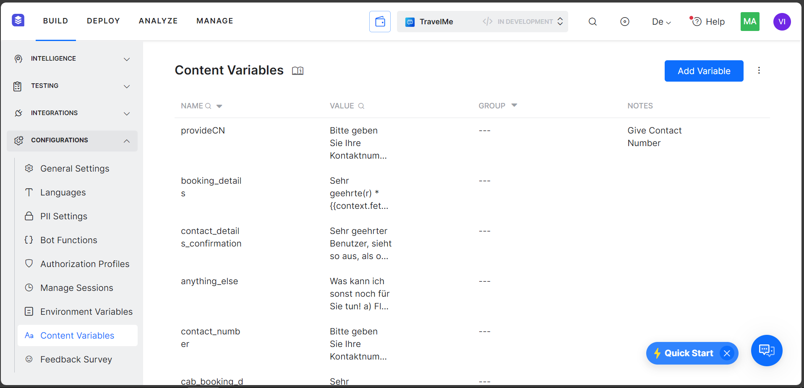

* 1. Train NLP with a few utterances for the above task in the new language you have enabled.

* 1. Add Faqs in the new language enabled. Share screenshot of conversation to show bot responses for FAQ qualification in the new language.

* 1. Attach a screenshot of the conversation you have with the bot in these multiple languages enabled

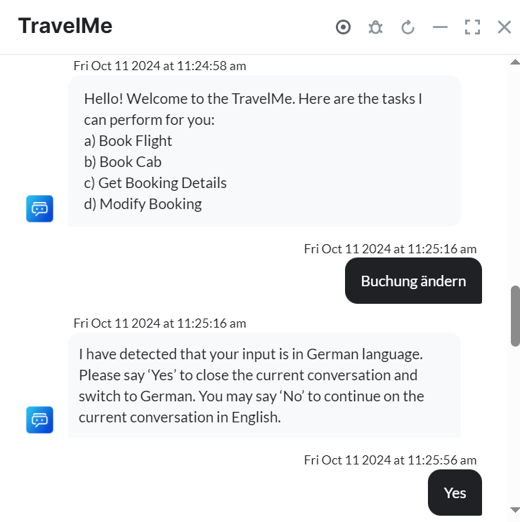

**FAQ:**

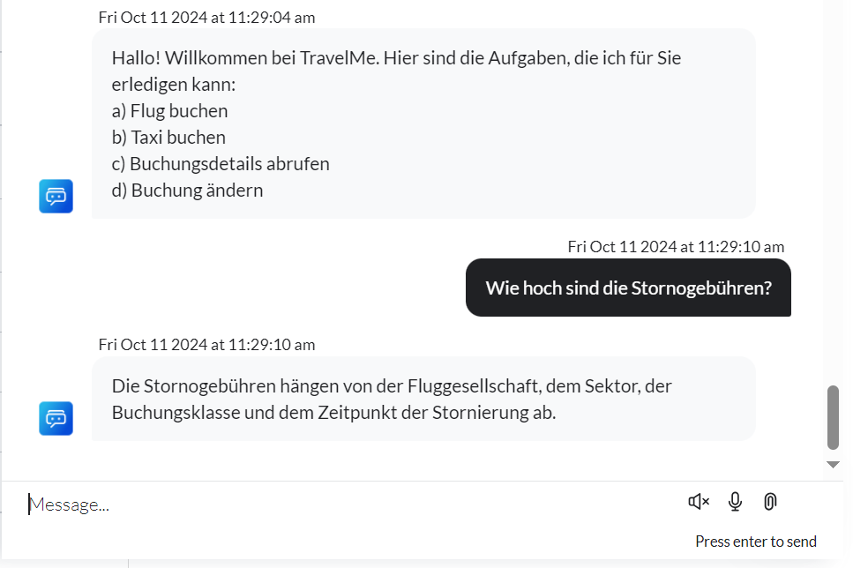

1. Using Public APIs, retrieve the Bots Change Logs.  
    (Share the API response screenshot when submitting the assignment).

* **Response File is attached to the submission mail**

1. Define a feedback survey (NPS) and initiate the feedback at the end of a few selected dialog tasks. Share the downloaded User feedback report from the Feedback Dashboard in the bot Analytics.

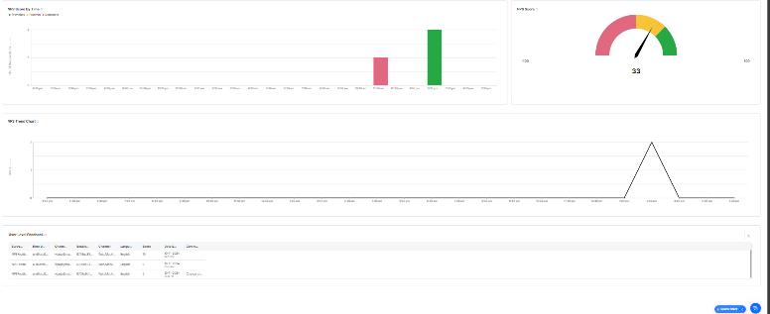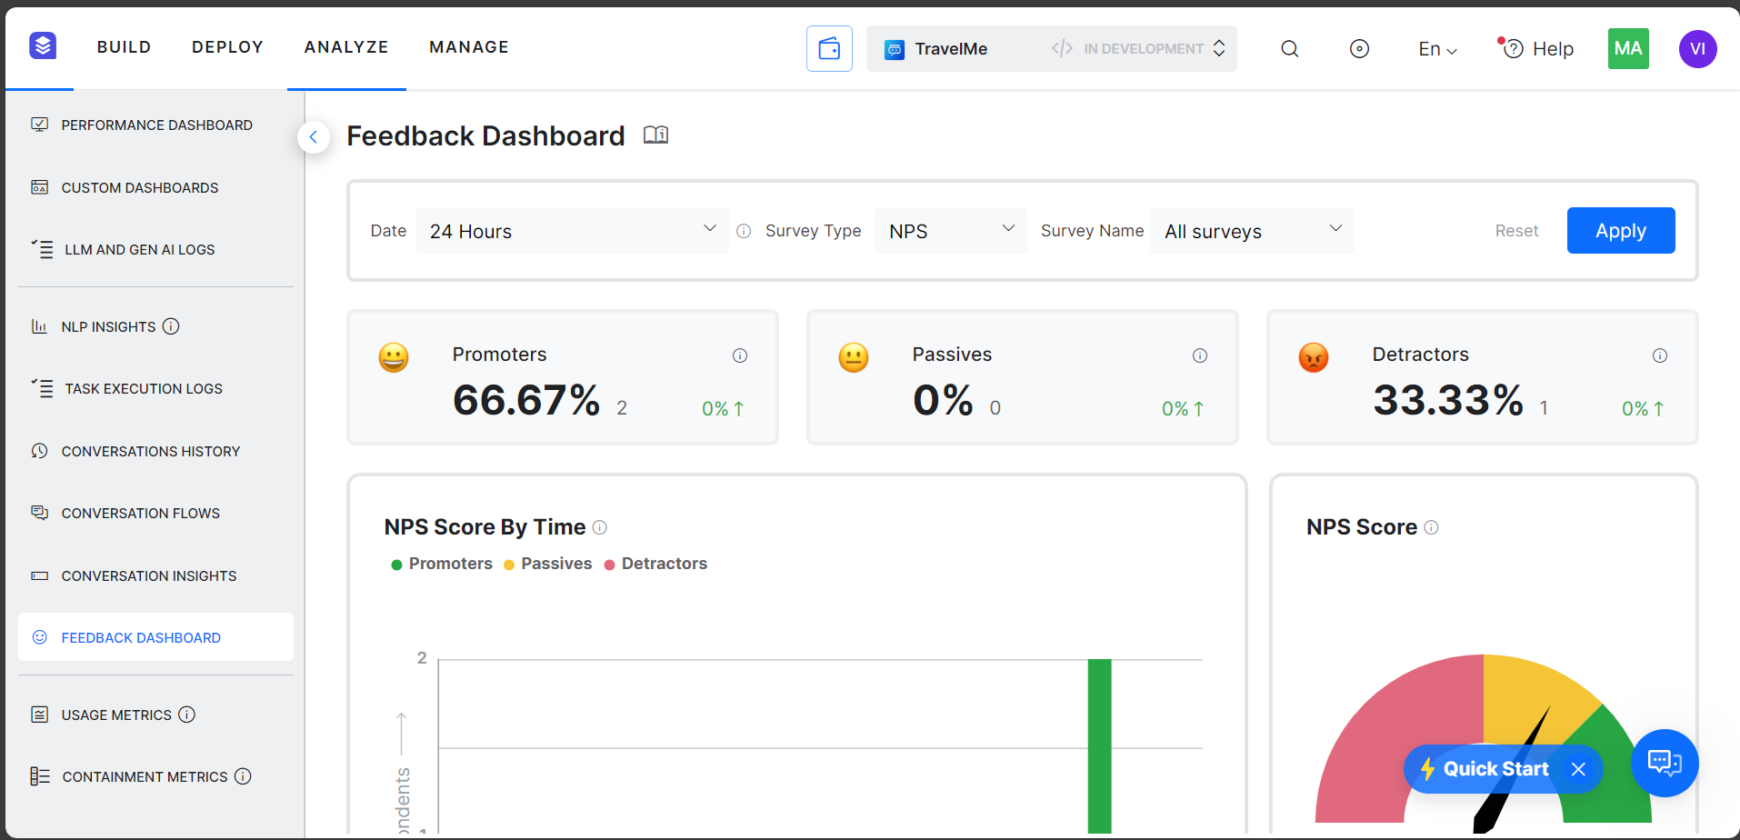

* **Downloaded report is attached to mail**

1. Create a task “Raise Issue”. The task should allow the user to raise his concern on the tasks available in the bot. The issue types can be related to “Tasks”, “FAQ response”, “User Experience”, “Incorrect Response” & “General”. The user should be asked to select one of these and describe the issue faced.

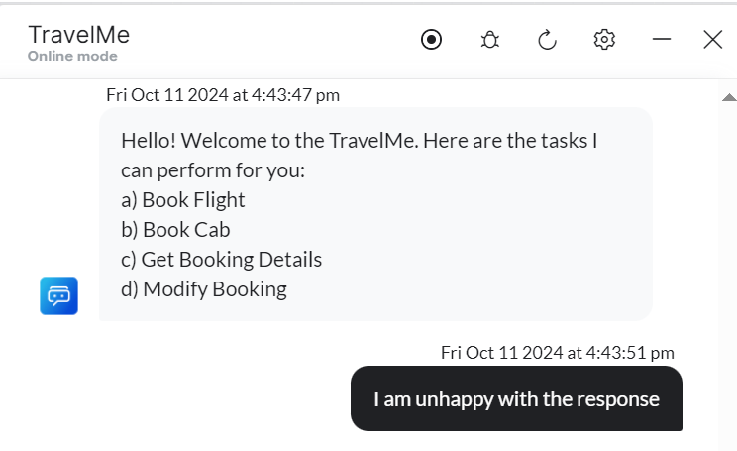

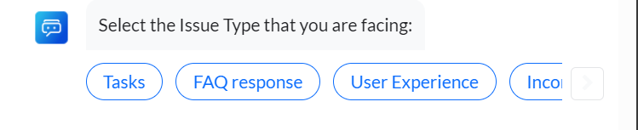

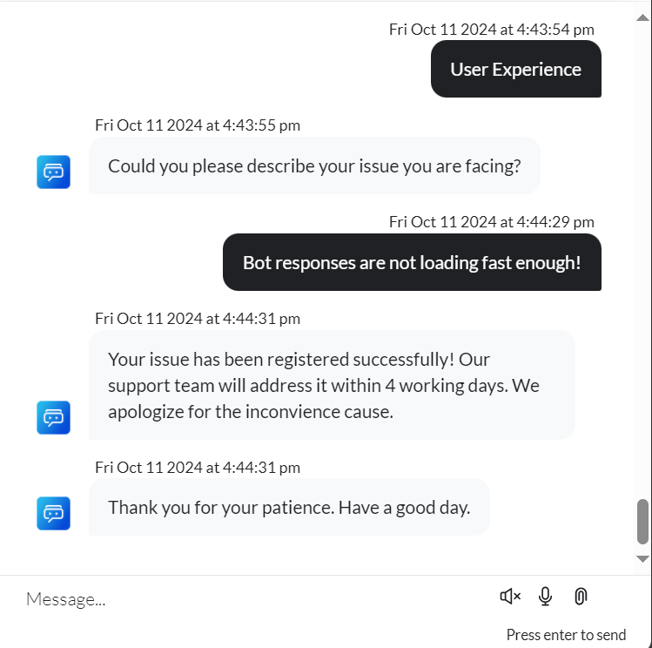

1. Trigger the “Raise Issue” task when the user expresses “dissatisfaction” (user says dissatisfied, unhappy or not satisfied) with the conversations.

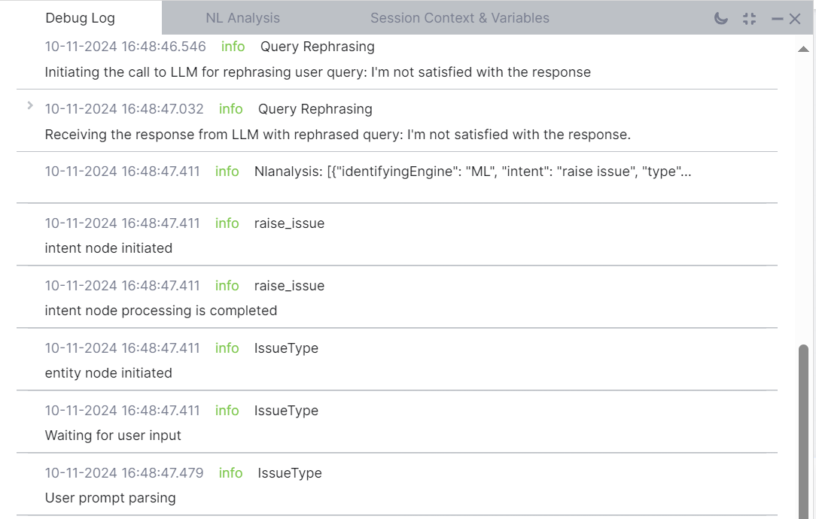



1. Now, using Custom Dashboard widgets, present date wise how many times the “Raise Issue” task was initiated. ( Use date, taskname from the Analytics dataset). Ensure to include developer interactions.   
   Attach screenshot of the custom dashboard widget.

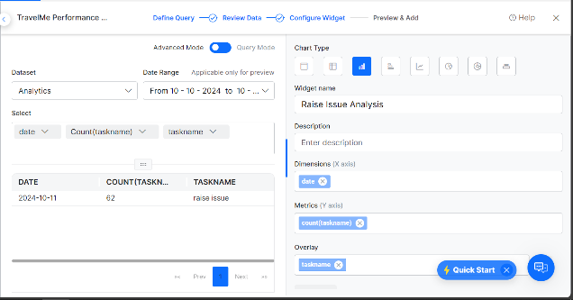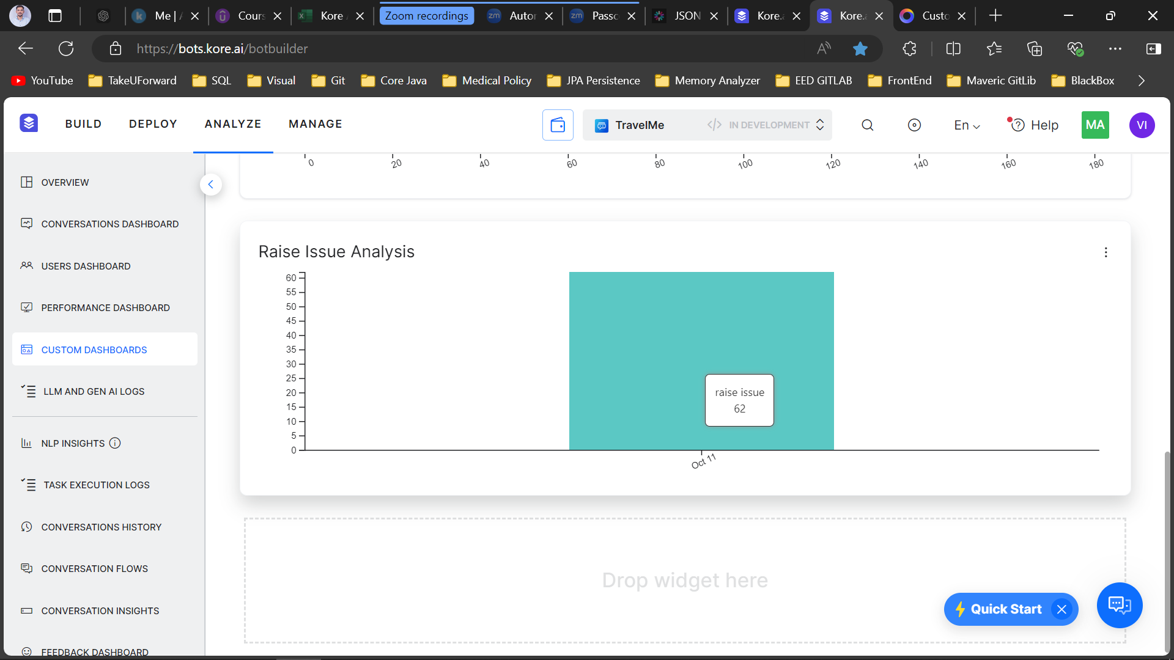

1. Enable the webhook channel. From Postman, send an utterance to trigger a task in the bot. (Share a screenshot of the bot response in Postman when submitting your assignment).

